**ENSEMBLE MODEL – META LEARNERS**

**BAGGING --homogenous**

**BOOTSTRAP AGGREGATION**

**10 KNN----**

**10 NB---**

**10 DTrees--🡪 RANDOM FOREST**

**BOOSTING – homogenous**

**ADAPTIVE BOOSTING**

**GRADIENT BOOST - GBM**

**XGBoost**

**CATBoost**

**LigthGBM**

**STACKING – 4 weak—2 KNN + 2 Dtrees**

**META MODEL ---**

**ASSEMBLING ++**

**Weak learners—LOGIT/SVM/DTRee/KNN/NB**

**2 more –STRONG LEARNER**

**DTRee – OVERFITTED --**

**BAGGING –**

**BOOTSTRAP AGGREGATION**

**BAGGING_DTREE===RANDOM FOREST - --- 1000 DTRee**

**BAGGING_KNN**

**BAGGING_NB**

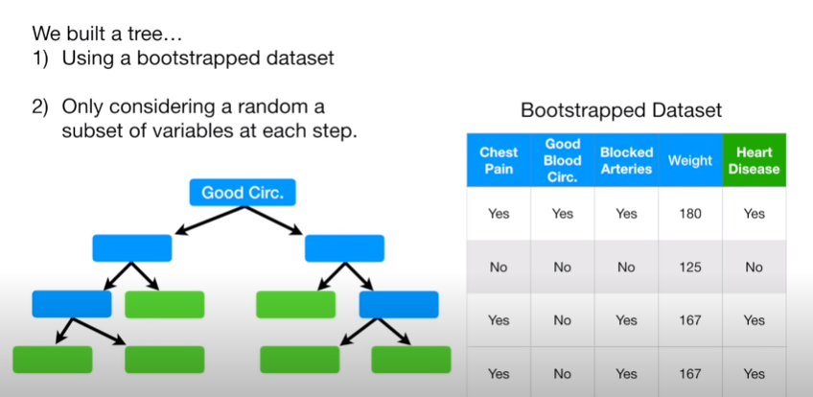

BAGGING MODELS are PARALLEL model ---NOT SEQUENTIAL

DTREES in RF are DEEP TREES – NOT SHALLOW TRESS – NOT STUMPS

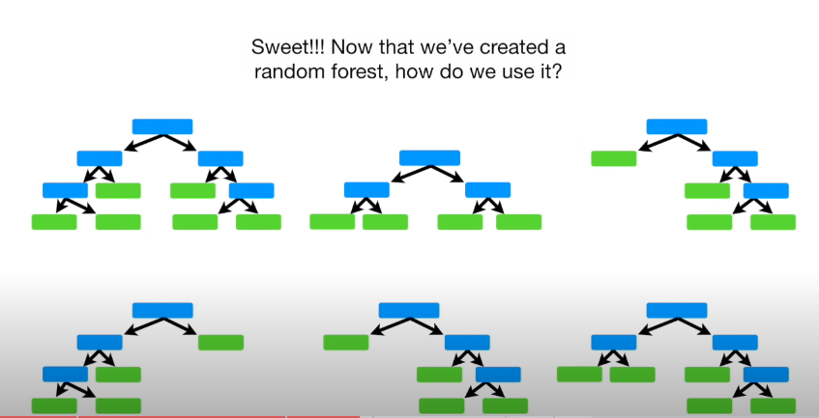



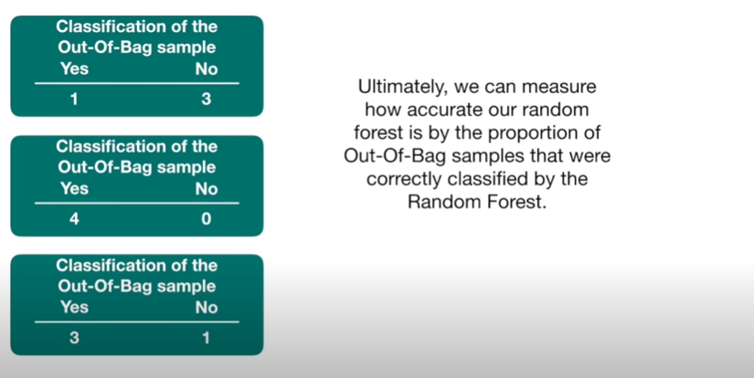

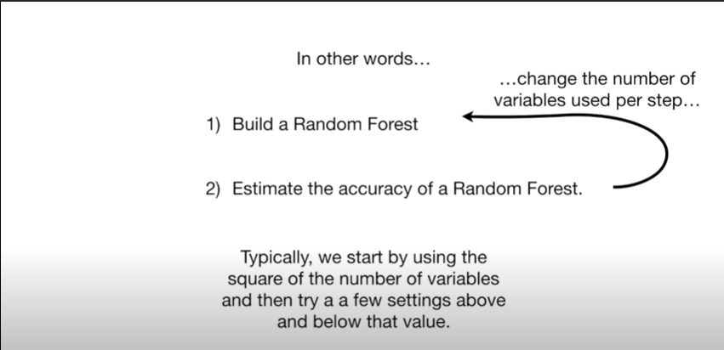

OOB ERROR

**BOOSTING**

**--- ADAPTIVE BOOST -- Gradient Boost Model [GBM] -- Xtreme Gradient BOOST – LIGTHGBM -- CATBOOST**

BOOSTING – ADABOOST

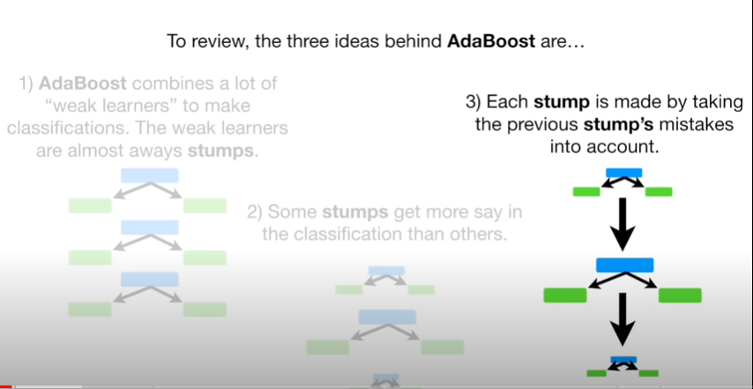

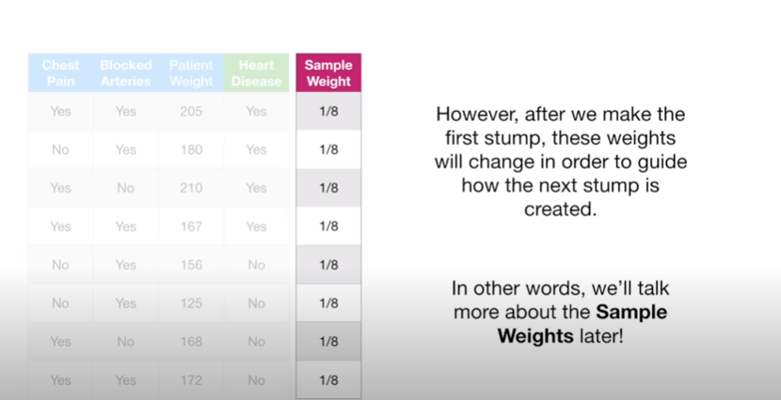

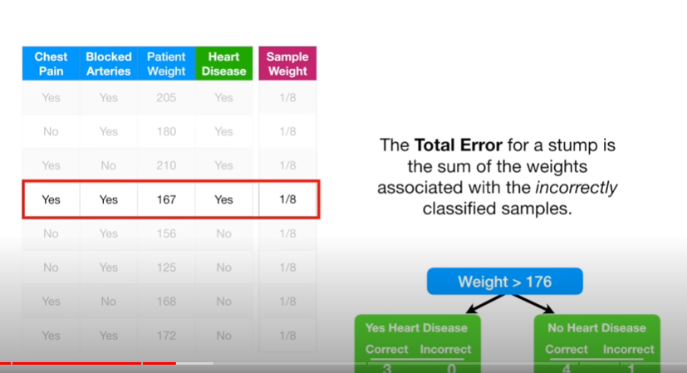

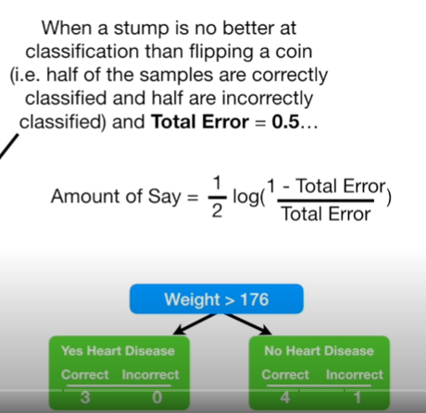

This formula is for misclassified records

New weight = Sample weight*exp(amount of say)

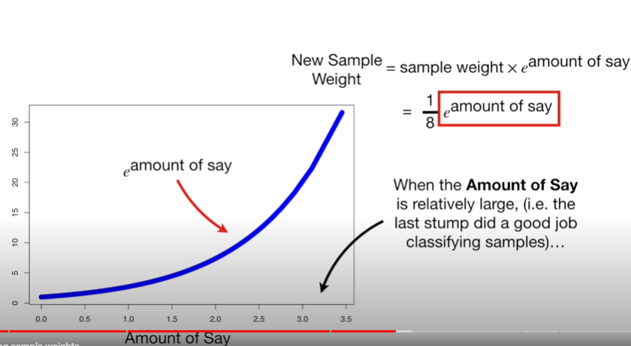

This formula is for correctly classified records::

New weight = Sample weight*exp(- amount of say)

